TERM PROJECT: IRIS-BASED BIOMETRIC IDENTIFICATION

Justin Parks & Richard Solotke

CSSE 490 – Image Recognition
May 19, 2006

ABSTRACT
This paper describes the results of developing software to perform biometric identification of humans based on the information contained in an image of the individual’s iris. The intended classifier is a nearest-neighbor classifier using Hamming distances. The feature vectors used in the classification contain the thresholded response of Gabor wavelet texture filters applied to the cropped and normalized iris image. No provisions are taken for occlusion due to eyelashes or eyelids, differences in lighting or rotation, or irregularly-shaped irises.

1. INTRODUCTION

The problem that this experiment was intended to address is that of biometric identification of a human being. There are countless applications in which identification of individuals is necessary—from automatic teller machines to military bases—, and the use of biometrics is one way to make the process both more efficient and more accurate. Among the different popular biometrics, iris images are extremely appealing due to their very high accuracy and very low intrusiveness. Irises are more accurate than fingerprints since identical twins share the same fingerprint but different iris patterns. The only widely-studied human biometrics that outperform irises in terms of accuracy are retinas and DNA, but both of which are much more difficult to obtain samples of. As appealing as iris-based identification is, it has already been successfully implemented in public use for automatic teller machines. Papers published in major professional journals describe a few different successful algorithms.
This paper describes our software algorithm, which we designed to incorporate aspects from multiple sources of our research but which we were only able to partially implement in the available time. We obtain a feature vector from each iris image which we pass to a nearest-neighbor classifier that is implemented to use Hamming distances for classification. The features analyzed are texture features obtained by applying Gabor wavelets to a normalized image. The normalization is accomplished by converting the bounded iris image from Cartesian coordinates to a doubly-dimensionless pseudo-polar coordinate system. The initial location of the pupil-iris and the iris-sclera boundaries is accomplished with a Hough transform.

2. METHODOLOGY AND RESULTS

Hardware to capture iris images is outside the scope of this project. We use publicly-available images that were carefully captured under ideal conditions for iris recognition. The images we used are all from the same online database, courtesy of Michal Dobeš and Libor Machala, and available at http://phoenix.inf.upol.cz/iris/. An example (subsampled by two) is given below as Figure A. The images are all taken under similar conditions and so are roughly similar in iris size and position. The images themselves are each 576 pixel by 768 pixel 24-bit RGB images stored in PNG format. There are three images of each (left and right) iris of 64 test subjects. They were scanned by a TOPCON TRC50IA optical device connected with a SONY DXC-950P 3CCD camera [2].

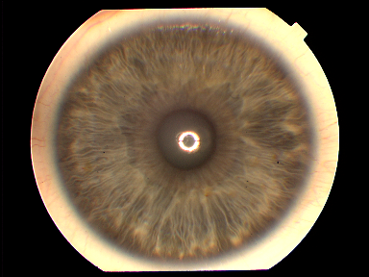

Fig. A. An example image from the database at http://phoenix.inf.upol.cz/iris/. This project was carried out using images exclusively from this public database. The relative similarity of all the images contained therein simplified our task.

Since we focused on the iris recognition stage of the entire iris biometric process and because the database we used had already been processed to find each iris, center the images and crop much of the original source, we were able to bypass a few of the common challenges of a full system beginning with the acquisition stage. The first thing needed for the eventual normalization then, is to locate the pupil-iris and the iris-sclera boundaries so that the working area, iris separated from the pupil and sclera, can be isolated. We do this using a Hough transform algorithm, taken and modified from [1]. This requires first that we acquire some edge information. We apply horizontal and vertical Sobel edge operators on a grayscale version of the image in question to obtain the initial information. The resulting magnitude information is then processed to select which pixels will vote in the Hough algorithm. An attempt is made to connect regions of high magnitude together that occur near the sought-after boundaries using erosion and dilation. Additional processing was originally implemented, but it was found that the speed tradeoff between the voting and the preprocessing was near equal. This process results in a set of edge magnitudes and directions that will be used to identify the iris boundaries. These sets are displayed as grayscale images in Figure U. The magnitude image has been thresholded to identify which pixels should be allowed to vote in the Hough process.

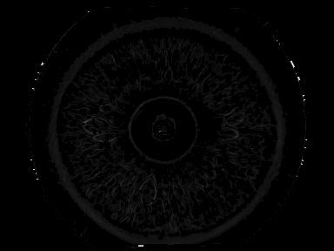
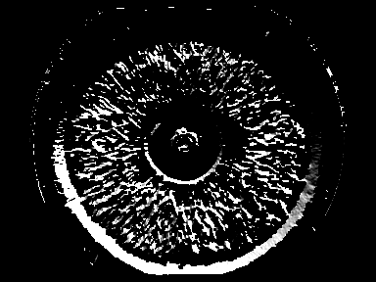

Fig. U. Magnitude of gradient (top) and direction of gradient (bottom) images. The magnitude image has been altered such that pixels whose magnitudes were lower than a fixed threshold are now set to zero to signify that they are not to be voters. Its values lie between zero and one, whereas values in the direction image lie between –Π and Π.

Once we have identified which pixels will be allowed to vote, we are ready to conduct voting for the pupil-iris boundary. The Hough algorithm simply allows each voting pixel to cast votes for circles of certain radii on which that pixel lies. We modified this to prevent casting votes for circles whose centers are too far away from the center of the image. This modification ensured that we ignore circles that could not possibly correspond to a boundary of the iris due to the uniform nature of our image dataset. Once voting is complete, we take the set of circles (defined by radius and coordinates of center) that received the maximum number of votes to be the initial set of pupil-iris boundary winners. In most cases, this procedure yielded only one initial winner; when it yielded more than one, the choice of which circle to select was made arbitrarily.
Once the pupil-iris boundary has been determined, voting for the iris-sclera boundary is conducted in the same manner as was that for the pupil-iris boundary except, of course, that different radii are considered. More often than the first round of voting, this round identified more than one initial winner. Of these initial winners, the one whose center was closest to the center of the winning pupil-iris boundary was chosen to be the winning iris-sclera boundary. An example of this situation is shown in Figure Z, where the green circle is the one that was chosen as the final winner. Our method was relatively successful: we correctly locate almost every iris boundary. Figure X is a pseudocolor image portraying the successful location of both iris boundaries on an example image from our dataset.

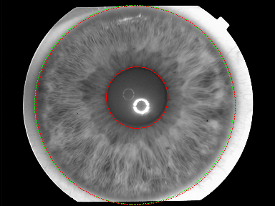

Fig. Z. Pseudocolor image showing initial iris-sclera boundary winners in red and final winner in green. The final winner was chosen as the initial winner whose center is closest to the center of the pupil-iris winner (also shown in red).

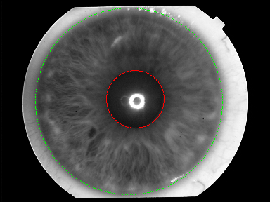

Fig. X. Pseudocolor image showing successful detection of pupil-iris (in red) and iris-sclera (in green) boundaries in an example image from the dataset. The original image is subsampled by two in each direction and converted to grayscale before the circles are marked on it.

Our method does fail, however, on images where the specular highlight in the pupil is large enough relative to the size of the pupil. In this case, too many votes are cast by the pixels that comprise the highlight, and these votes outweigh the votes for the pupil boundary that we are interested in. An example of this phenomenon is shown in Figure Y. The three images in Figure Y are different images of the same iris, and it is clear that in each image, the pupils are small enough to be confused with the highlight.

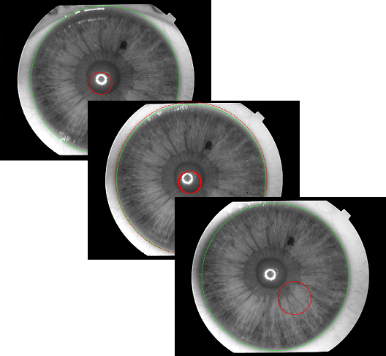

Fig. Y. Pseudocolor images showing failed detection of pupil-iris boundary (in red) due to confusion with specular highlight. This phenomenon was observed in situations where the size of the highlight is similar enough to the size of the pupil boundary. The three images shown are three different images of the same iris.

Scale normalization of the iris can be achieved by unrolling the iris into a rectangular form. This radial sweep can be performed by mapping each coordinate in the resulting output to a coordinate in the original image. This process may be described by:

I_{o}(X,Y) = I_{s}(x,y)
x = x_{pupil}(θ) + ((x_{sclera}(θ) – x_{pupil}(θ))Y/M
y = y_{pupil}(θ) + ((y_{sclera}(θ) - y_{pupil}(θ))Y/M
θ = 2πX/N,

as in [5], where the image I_{o} is the M x N output image and I_{s} is the original source image we are mapping from. The points (x_{pupil}, y_{pupil}) and (x_{sclera}, y_{sclera}) are the points on the pupil-iris and iris-sclera boundaries, respectively, at the given angle θ. This process causes the image to be scale normalized because it is stretched or compressed to fit the given rectangle. Additionally, this makes it much easier to do processing on the resulting image if one were to enhance the contrast, perform lighting adjustment, etc. on the texture. Feature extraction can now proceed on regular rectangular regions that can easily and accurately be located and matched in a test image.

3. FUTURE WORK

If we had more time available with which to expand upon our work, there are many improvements we could make. First of all, we were unable to implement the feature extraction and classification steps of our algorithm. Our obvious next step would be to implement texture feature extraction using Gabor wavelet filters such as the one shown in Figure W and then to implement a nearest-neighbor classifier using Hamming distances. However, even after completing this implementation, our algorithm would only be maximally successful when applied to images from the specific database we used because of the homogeneity of those images. Much time could be spent improving the flexibility of our algorithm to handle a more diverse set of images. Specific tasks in this area that have been studied by others in the field include lighting normalization, rotational normalization, and occlusion detection. The additional robustness that these improvements would provide would allow our algorithm to succeed when given images that were taken more naturally (less intrusively to the subject).

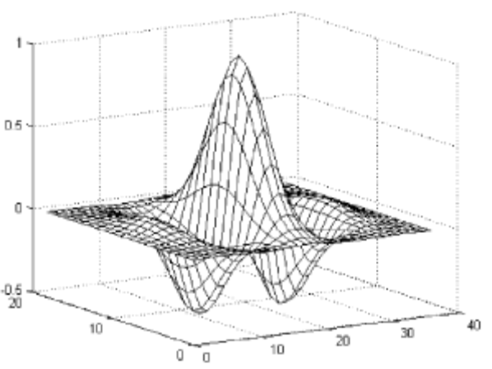

Fig. W. Gabor wavelet filter that would be used to extract texture features from the enhanced unrolled pseudo-polar images. The average response of this filter to spatial regions in the image would be thresholded to obtain feature vector elements. This image was taken from [5].

The raw output of the iris unrolling algorithm is likely in need of signal amplification in the form of lighting normalization and contrast enhancement. It is common for the optical hardware used in iris recognition systems to be infrared based, as this is known to reduce noise resulting from nonuniform lighting of the target. As a further step, the unrolled iris can be processed to subtract out the effects of nonuniform lighting. Ma et al. suggest in [5] a method that approximates the intensity variation across regions centered at each pixel in the image using means. The result is then extrapolated to the dimensions of the image and subtracted from the image to equalize the lighting effects. Then, also in [5], Ma et al. suggest histogram equalization on small regions across the image to increase the contrast. Results of this process would likely make features more strongly marked and cause stronger responses from the Gabor wavelets in addition to normalizing the effects of non-uniform lighting.
Our current algorithm does not account for the fact that the iris in a given image may be rotated slightly with respect to another image of the same iris. Ma et al. describe in [5] a technique to provide invariance towards rotation by simply generating several different pseudo-polar unrolled images of each iris image, each starting at a slightly different rotation. Since iris images can be assumed to be taken while the subject is sitting or standing vertically, there is only a small range of rotations that would need to be considered. As such, a feature vector can be extracted from each of the unrolled images and provided to the classifier.
Iris images are vulnerable to occlusion of the iris by eyelids and eyelashes; an example of this effect is shown in Figure Q. Huang et al. describe in [4] a method of locating any eyelids and eyelashes in an iris image in order to exclude them from the working area from which features will be extracted. They use a Hough transform to locate eyelids as well as simple directional edge detection to locate single eyelashes and variance thresholding of small spatial regions to locate multiple connected eyelashes.

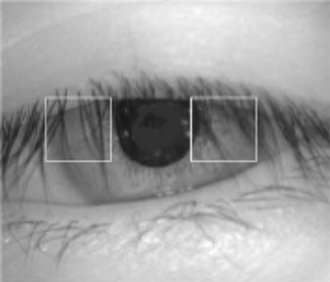

Fig. Q. Iris image in which the iris is occluded by both eyelids and eyelashes. Our current algorithm is not likely to be successful with this type of image. This image was taken from [5].

Another opportunity for future enhancement exists with our iris boundary detection algorithm. Our algorithm makes some assumptions about the iris images it receives that are actually not always true. Specifically, we assume that both the pupil-iris boundary and the iris-sclera boundary are circular and that they are concentric. Both of these statements are usually true, but not necessarily so. Even the dataset we used, in which care was taken to make the images as homogenous as possible, contains images of clearly non-circular irises such as the one in Figure P. It is obvious from the figure that with the assumption of circular iris boundaries, it is impossible to identify the entire iris-sclera boundary in this image.

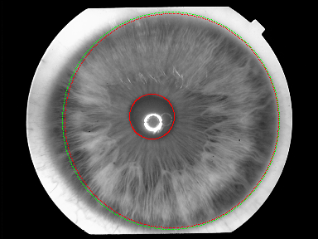

Fig. P. Results of iris boundary detection algorithm when applied to an image in which the iris-sclera boundary is clearly not circular. Additional time extending this project could be spent altering the algorithm to successfully find non-circular iris boundaries.

Other possible enhancements to our algorithm include experimentation with different feature extraction methods and different classification methods. For example, [3] employs principal and independent components analysis to determine features and Euclidean distances to perform matching. Also, plenty of time could be spent tweaking parameters to all parts of our algorithm, from the initial threshold to determine Hough voters to the final accept-or-reject threshold in the classifier. Thorough performance measurement could be carried out on each variation to determine which method and parameters achieve the highest rate of success.

4. CONCLUSIONS

Iris-based recognition is an incredibly useful biometric solution to the problem of human identification due in part to the minimally-intrusive nature of its data collection and to the accuracy and therefore security derived from the uniqueness of human irises. Successful implementations of the biometric exist, but the area still has room for improvement as it has by no means been studied completely. Our goal was to synthesize aspects of different published solutions into a working biometric identification system. Due to unexpected and unavoidable circumstances, we were only able to partially implement our design in the time available. We were relatively successful at the steps we did implement, and we feel confident that given additional time, we could complete the implementation.
5. REFERENCES

- Boutell, Matthew. Hough Transform. November 2001.
- Dobeš, Michael and Libor Machala. Iris Database. http://phoenix.inf.upol.cz/iris/.
- Dorairaj, Vivekanand, Yash N. Shah, and Natalia A. Schmid. Exploring and Developing Processing Techniques for Iris Recognition System. Lane Department of Computer Science and Electrical Engineering.
- Huang, Ya-Ping, Si-Wei Luo, and En-Yi Chen. An Efficient Iris Recognition System. Proceedings of the First International Conference on Machine Learning and Cybernetics, pp. 450-454, November 2002.
- Ma, Li, Tieniu Tan, Senior Member, IEEE, Yunhong Wang, Member, IEEE, and Dexin Zhang. Personal Identification Based on Iris Texture Analysis. IEEE Transactions on Pattern Analysis and Machine Intelligence, Vol. 25, No. 12, December 2003.
- Negin, Michael, Thomas A. Chmielewski, Jr, Marcos Salganicoff, Theodore A. Camus, Ulf M. Cahn von Seelen, Péter L. Venetianer, and Guanghua G. Zhang. An Iris Biometric System for Public and Personal Use. Computer, pp. 70-75, February 2000.
- Shapiro, Linda G. and George C. Stockman. Computer Vision. Prentice Hall: Upper Saddle River, New Jersey, 2001. pp. 554-561.

